EFCC Brisbane Run 22 April 2012
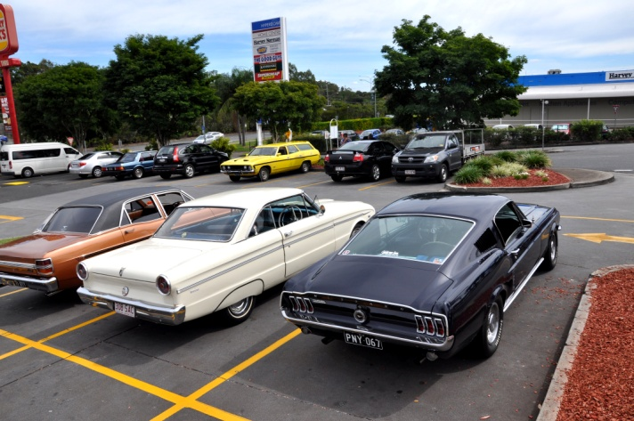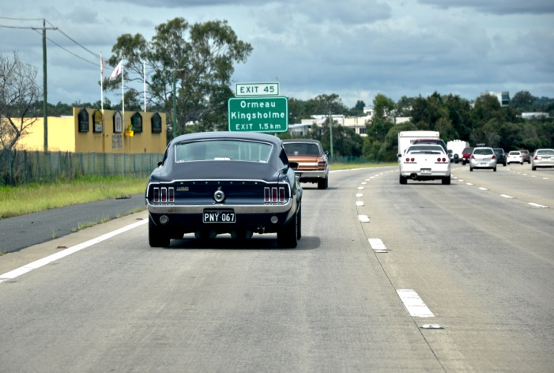
Southside meeting place Cruizin’....keeping an eye on the ‘stang radiator
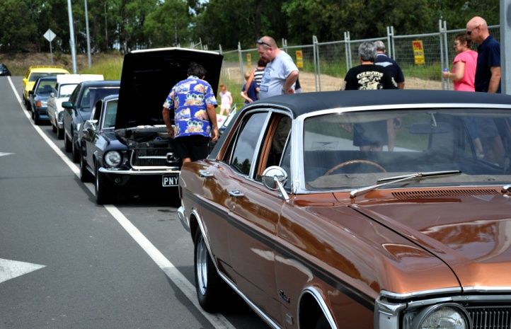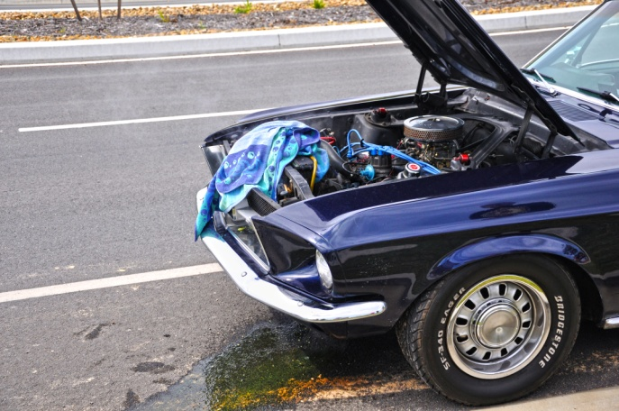
One HOT 67 Mustang......... Anybody got some coolant ?
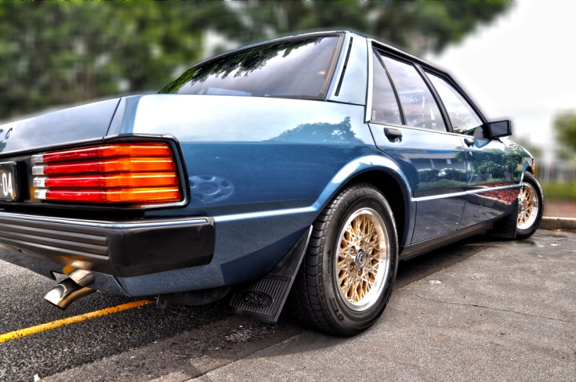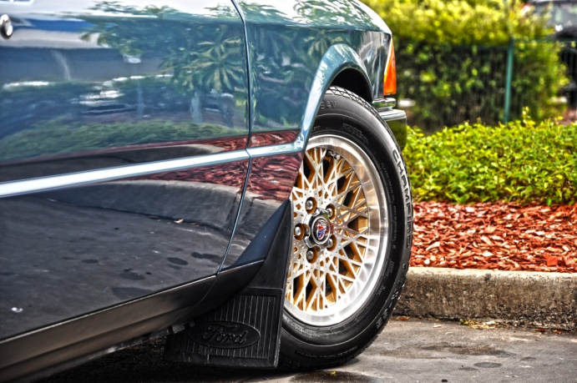
Noel’s super smooth XE Falcon Below: The Club run gang....
